* **Activity 10:**

Deleting a Row from a Table

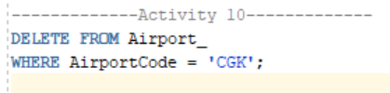

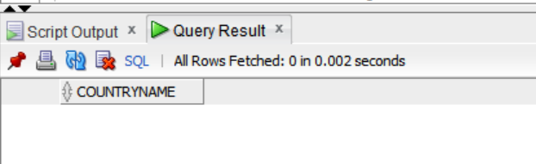OUTPUT: